A000-Afr-Yoruba-Female Divining tapper-Iro Ifa-Orisha Oshun-19th c

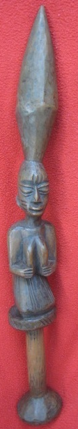 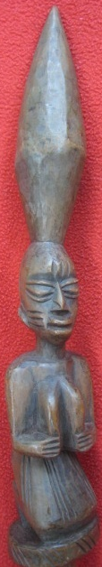 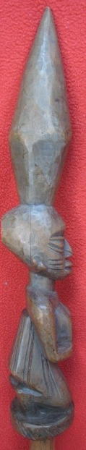 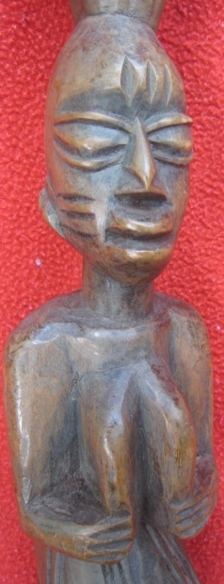 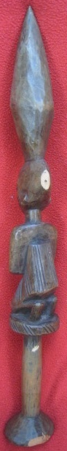

Figs. 1-5. Afr-Yoruba-Female Divining tapper-Iro Ifa-Orisha Oshun-19th c

**Accession No.**

**Formal Label:** Afr-Yoruba-Female Divining tapper-Iro Ifa-Orisha Oshun-19th c

**Display Description:**

This Yoruba wooden divining tapper or "Iro Ifa" was once part of the Honolulu Art Museum's collection and was acquired by the museum from missionaries in the nineteenth century. It features a carved image of the Orisha Oshun, with three scarification marks denoting her tribal group and naked except for with a skirt also marked by three stripes. This kneeling gesture has been related to the practice in traditional life of kneeling in submission to authority which fits the practice of divination since, when the diviner or "babalawo" greets visitors by striking the divining tapper on the divining tray there is an implicit request made to the entrant to bow to his authority (Odugbesan 1969: 202; Thompson 1976: CH 5/3-4). Therefore, this sculptural posture reflects that of the suppliant in search of a divining request.

**LC Classification:**

**Date or Time Horizon:**

**Geographical Area:**

**Map:**

**GPS coordinates:**

**Cultural Affiliation:**

**Medium: wood**

**Dimensions: H** 24 in, W and D 4 in

**Weight:**

**Condition:**

**Provenance:** Honolulu Art Museum's collection that was acquired by the museum from missionaries in the nineteenth century

**Discussion:**

**References:**

Odugbesan, C. 1969. Femininity in Yoruba religious art," *Man in Africa*, eds. M. Douglas and P. M. Kaberry. London: Tavistock, pp. 199-211.

Thompson, R. F. [1971] 1976. *Black Gods and Kings: Yoruba Art at UCLA*. [Originally published as: Occasional Paper, No. II, Museum and Laboratories of Ethnic Arts and Technology, University of California, Los Angeles] (Bloomington, London: Indiana University Press, 1976).